Database System Engineering and Distributed Backend Development
Course Code: 25CS1302E
SKILL SESSION 4 AND 5
Name: Kunamaneni Bhavana
Roll no: 2520030003

INSERT CUSTOMER DATA
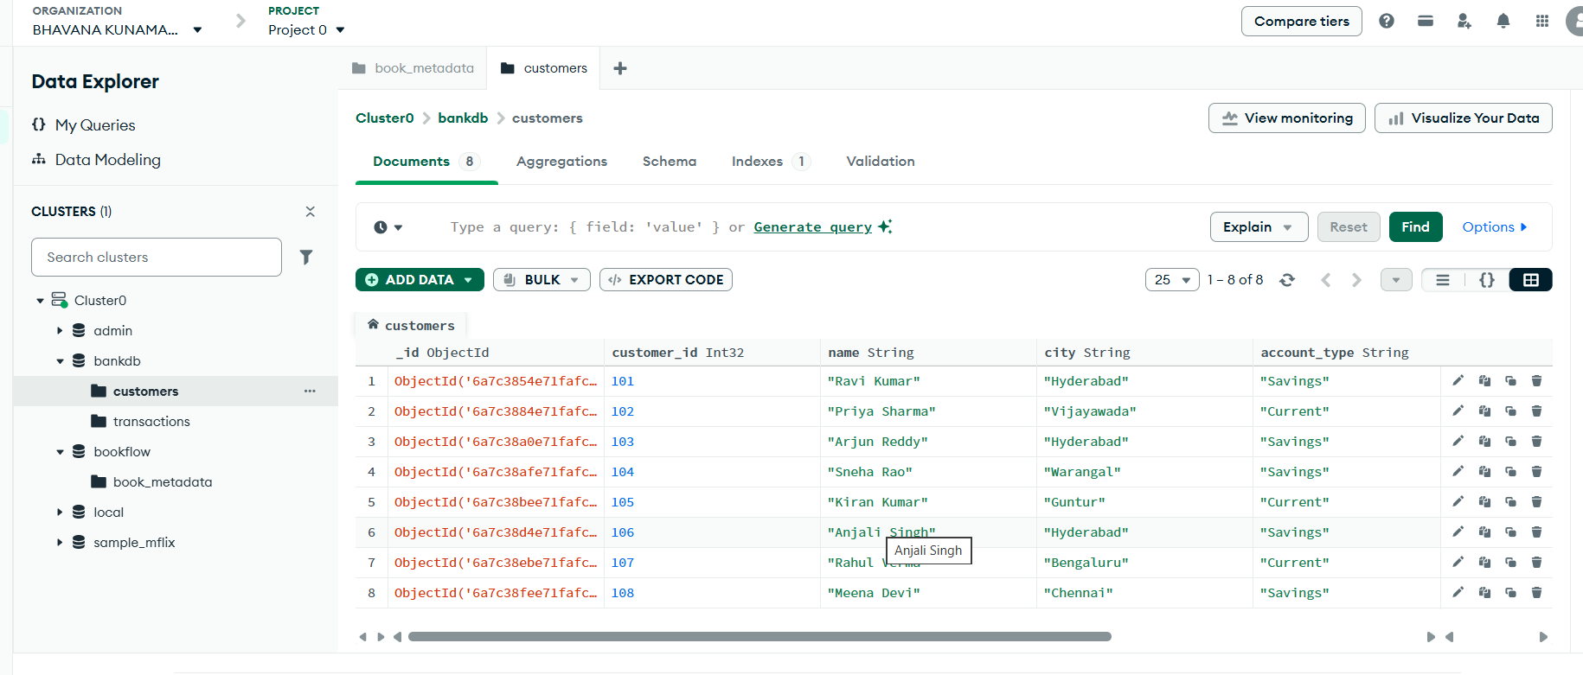

INSERT TRANSACTION DATA
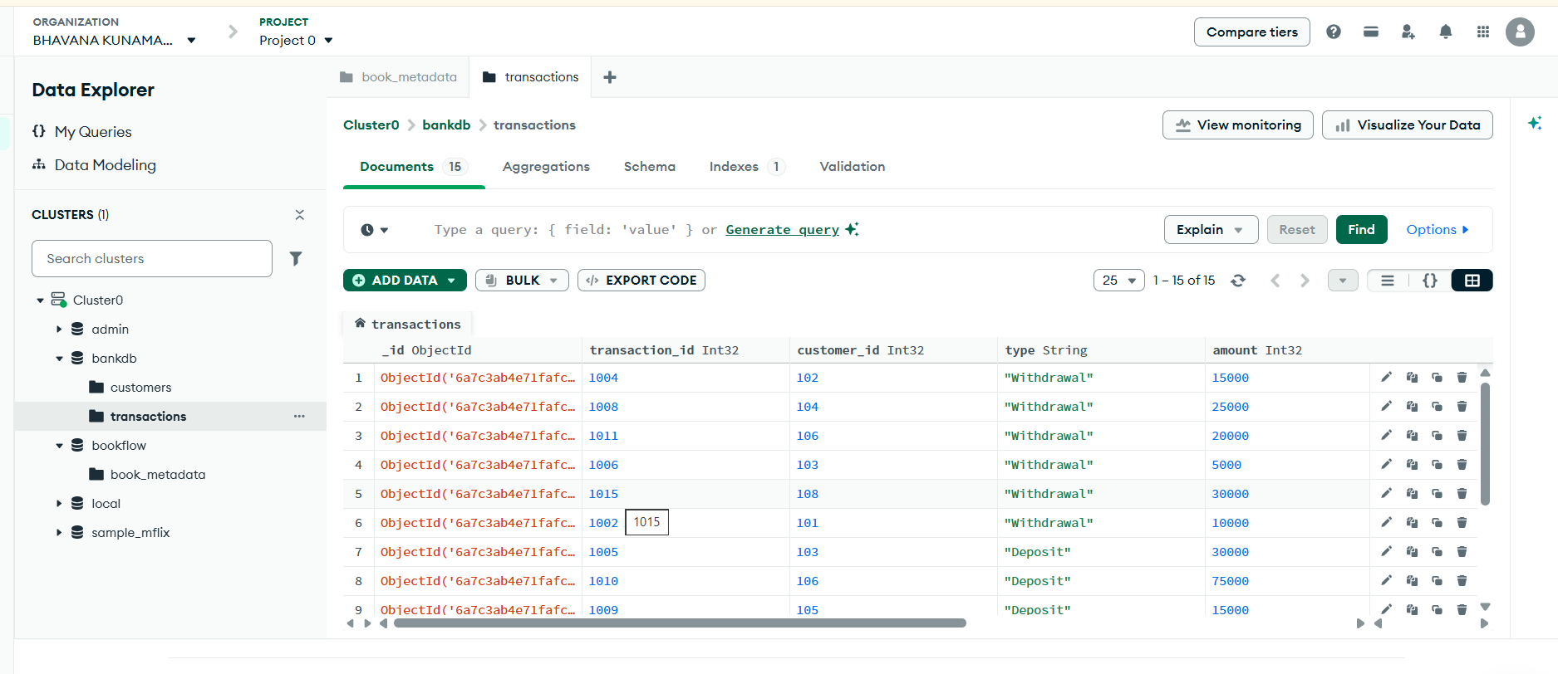
FIND ACTIVE CUSTOMERS
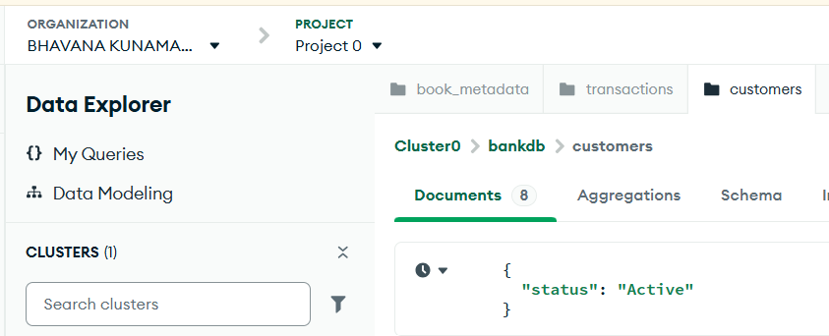
Output
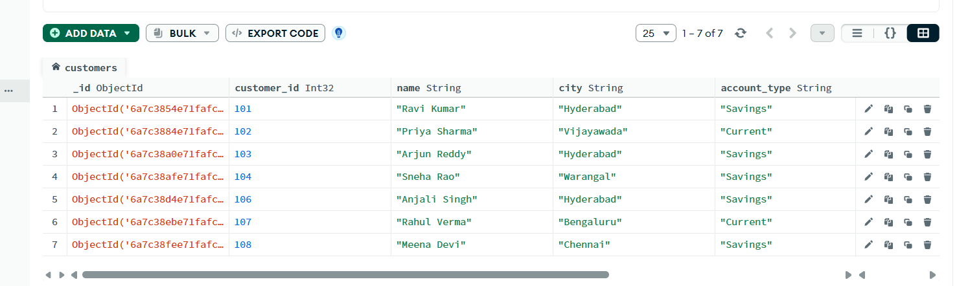
FIND CUSTOMERS WITH BALANCE GREATER THAN 100000
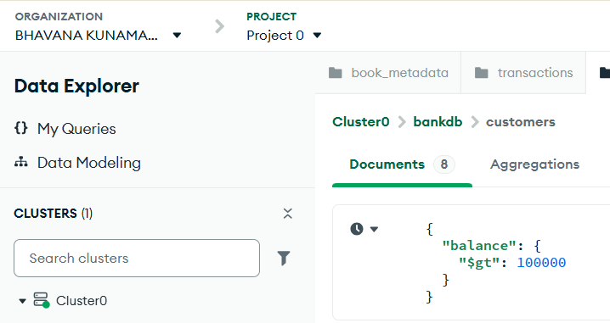
Output
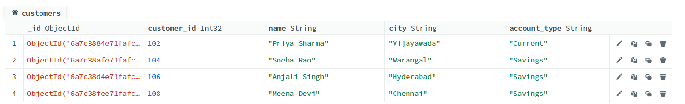

FIND HYDERABAD CUSTOMERS
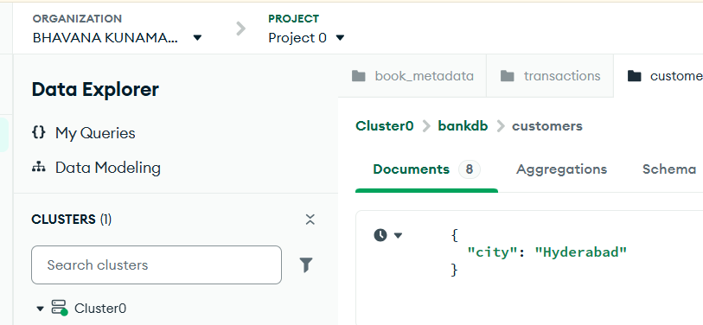
Output
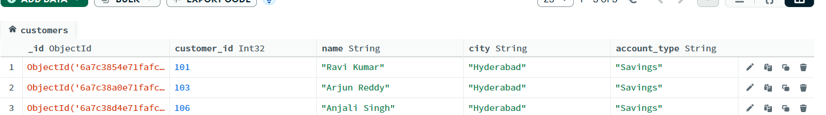

FIND SAVINGS ACCOUNT CUSTOMERS
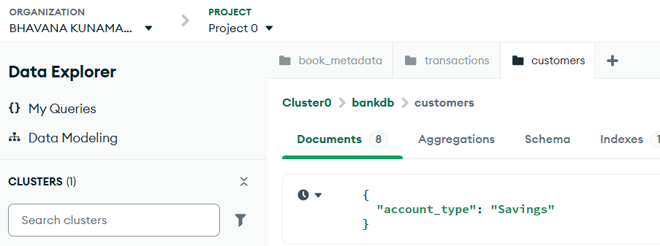
Output
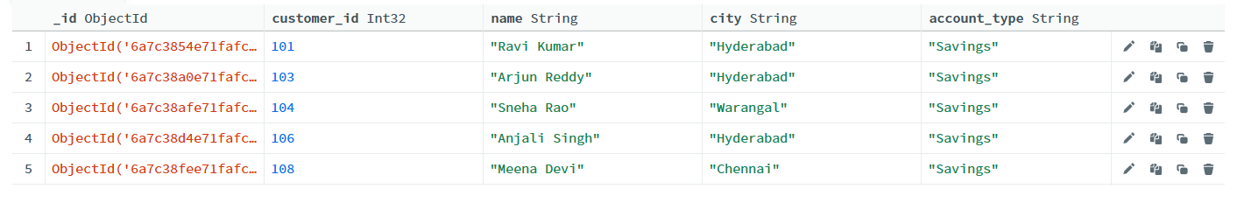

FIND TRANSACTIONS GREATER THAN 20000
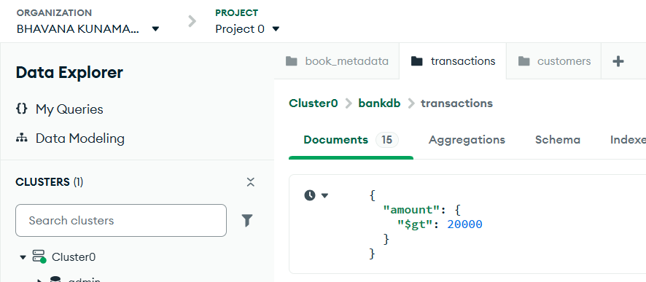

Output
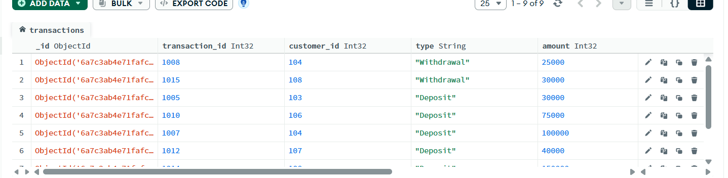

FIND DEPOSITS
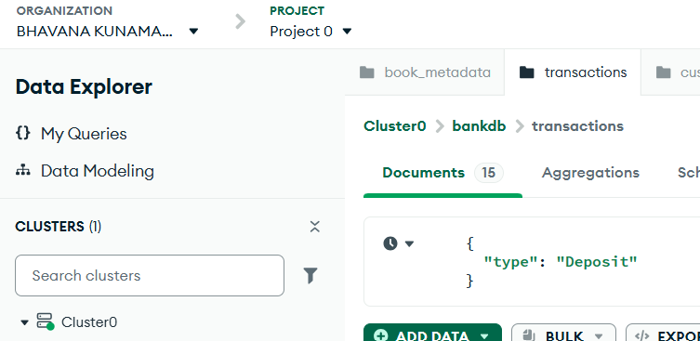
Output
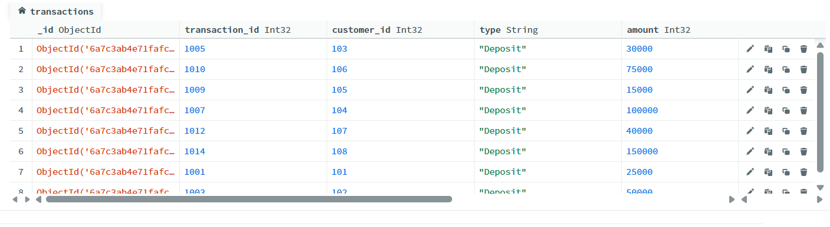

FIND ATM TRANSACTIONS
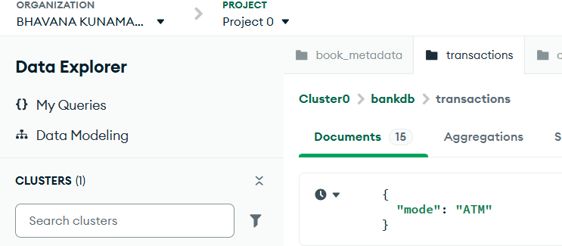
Output
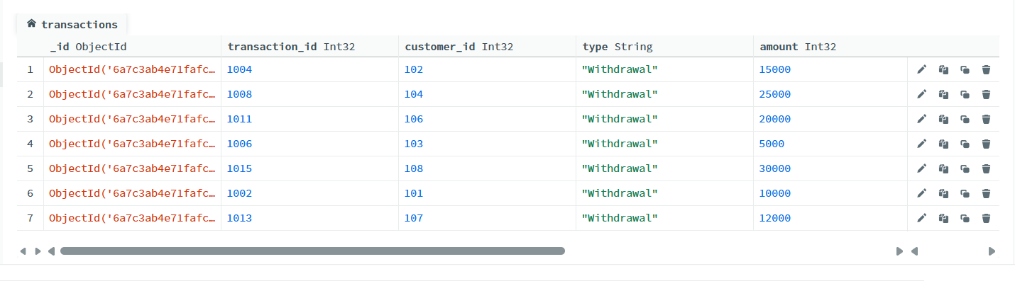
FIND DEPOSITS GREATER THAN 50000
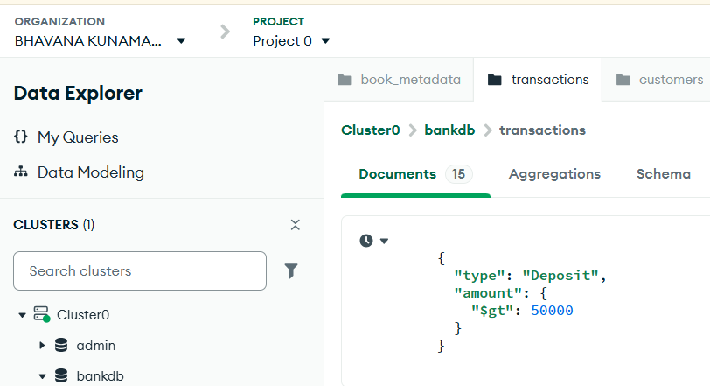

Output
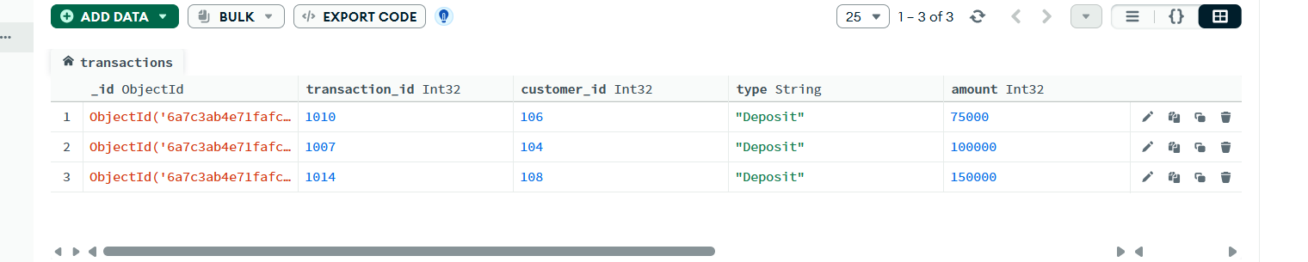

FIND HYDERABAD CUSTOMERS WITH HIGH BALANCE
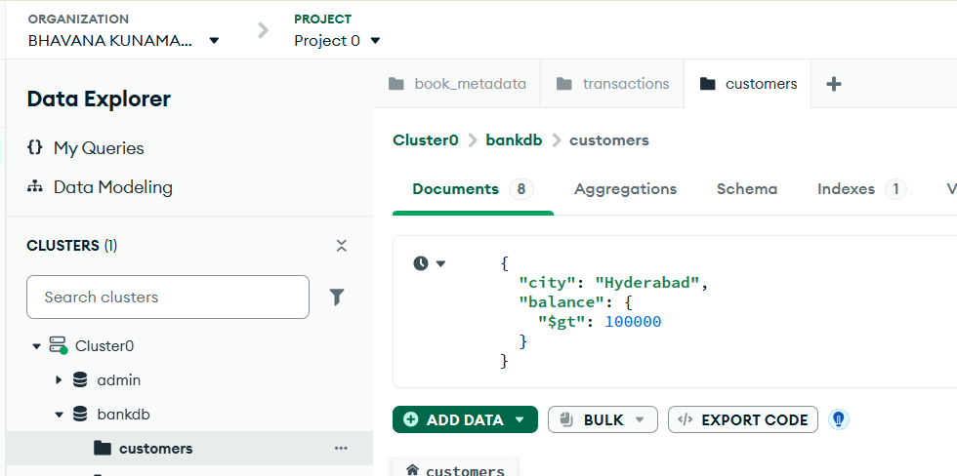
Output
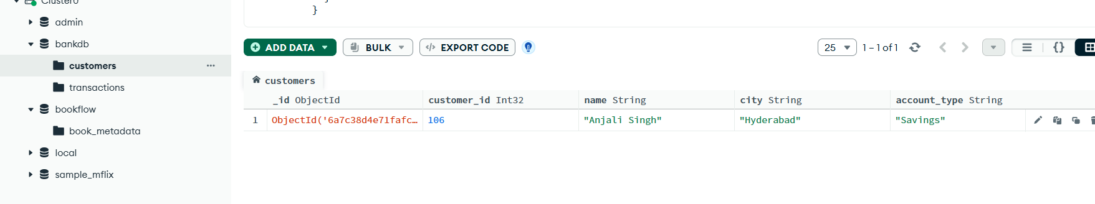

FIND CUSTOMERS IN MULTIPLE CITIES

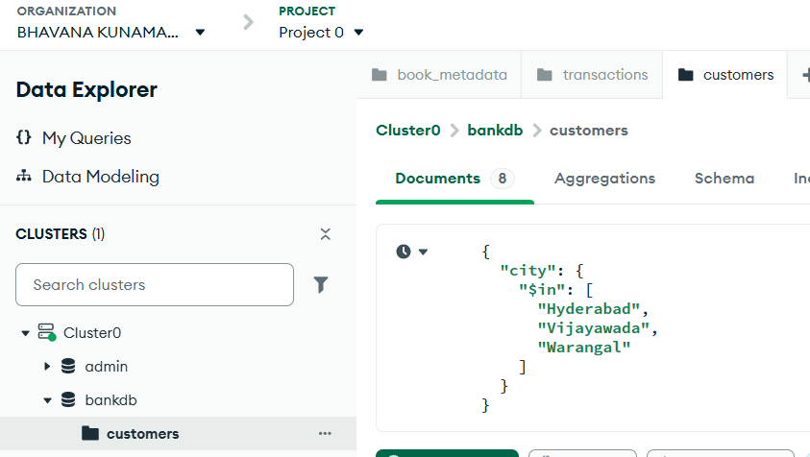

Output
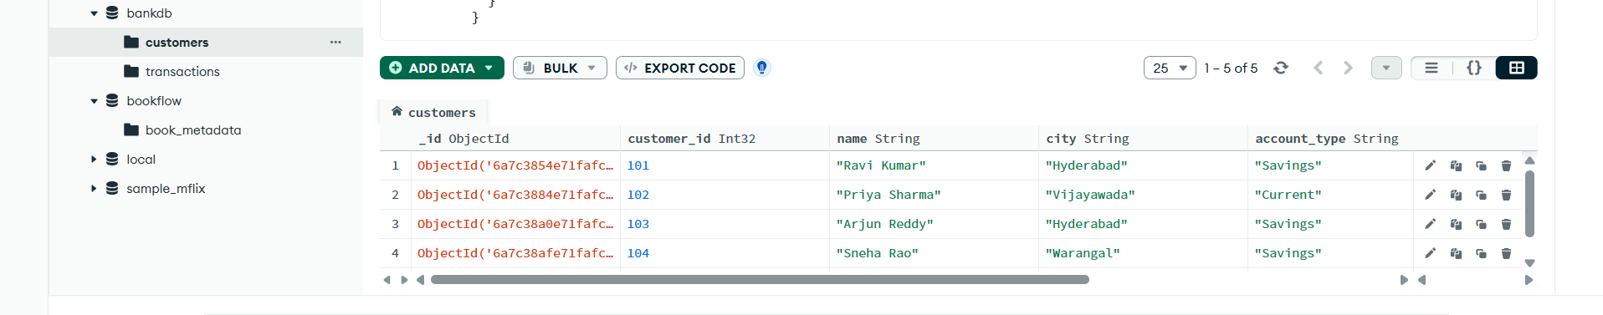

SORT CUSTOMERS BY BALANCE
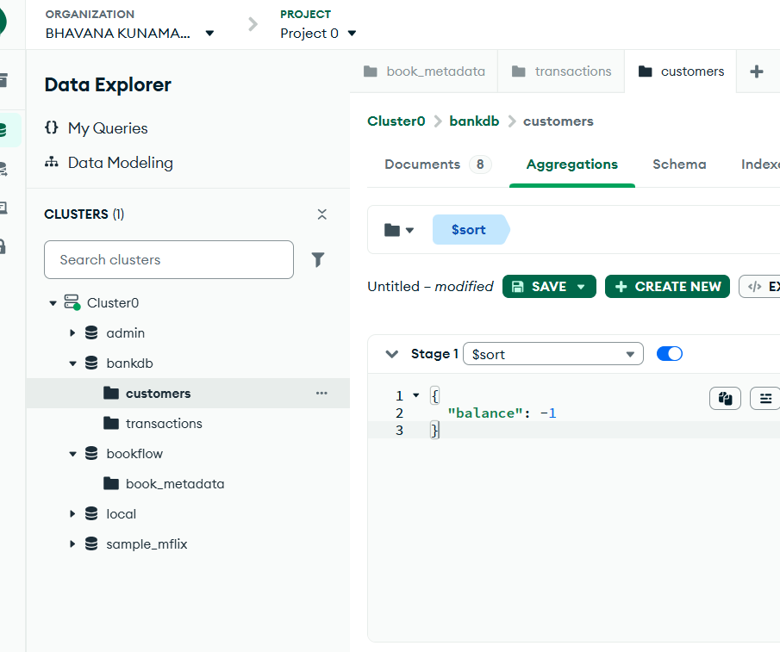
Output
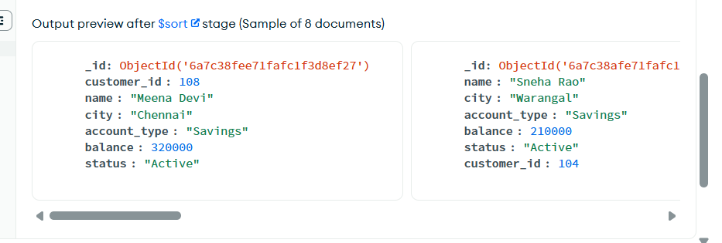

CALCULATE TOTAL TRANSACTION AMOUNT
